**Class In Java**

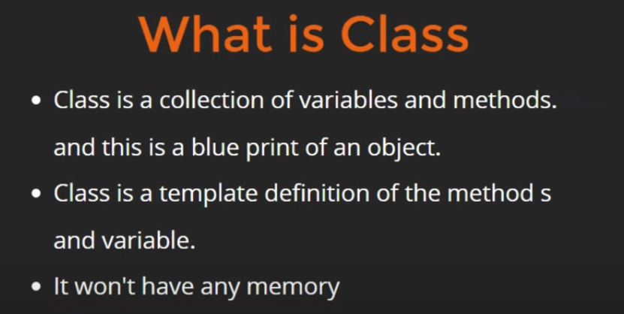

**Note:**

* **It is not necessary for all the classes to have a main method.** main method is used as an entry point for java applications. So once you have entered the java code using main method of a single class you can call other classes code form there.
* By default, in a whole program or File that class only execute automatically having main function/inside inside it. In that main method, we can call rest of the other classes & methods.
* While creation/definition of classes, it don’t have any memory. But as we create it’s instance, it start containing memory.
* Variables == Properties == State  
  Methods == Executable Code
* Methods: Executable code that manipulates state and performs operations  
  Constructors: Executable code used during object creation to set initial state. Constructor doesn’t have return type.

**Example:**

public class Main {

// main Method

public static void main(String[] args) {

User usr1 = new User();

usr1.getData();

usr1.name = "Kumar";

}

}

class User {

public int data = 20;

public String name = "Chandan";

public void getData() {

System.out.println("GOT DATA");

System.out.println(name);

}

}

**Output:**GOT DATA  
Chandan